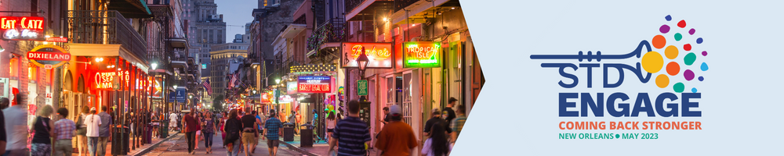

Date

Dear <supervisor’s name>,

I would like to attend the National Coalition of STD Director’s (NCSD) Annual Meeting, STD Engage, from May 16-18, 2023, in New Orleans, LA. STD Engage is the only national meeting that brings together state and local sexual health professionals and their community-based partners for cross-jurisdictional collaboration and problem-solving. Attendance at this meeting will enable me to attend a variety of training and educational sessions and connect with a network of colleagues from health department programs across the country.

I plan to achieve the following objectives: [Examples – I plan to bring back information from three research studies that affect our work on XXX. I plan to meet with five organizations that we could partner with on XXX.]

- [Insert your first objective here.]
- [Insert your second objective here.]
- [Insert your third objective here.]

All of the sessions will provide practical examples to strengthen [insert program/health department/organization], and relay the tools needed to serve our community. Each session will provide slides and other learning materials that I can bring back and share with my colleagues.

This year’s theme is “Coming Back Stronger” and will focus on STD prevention topics, such as program innovation, health equity, policy, outreach, and more. The theme intentionally stresses coming back stronger because COVID-19 and the recent mpox outbreak has impacted sexual health infrastructure and departmental capacities in a historically unprecedented way. Therefore, this meeting is a vital opportunity to reconnect with the public health workforce behind STD prevention and leverage our resiliency to move forward.

In fact, the protection of public health remains dependent on such gatherings to facilitate sensible solutions to our post-pandemic “new normal” syndemics. At STD Engage, the time we spend together in a creative learning environment will offer valuable, tangible information to uplift and improve the work of individuals across the STD sector.

Still, no matter how critical this moment may be for public health, I understand we have to be conscientious of where we spend money. Therefore, I have broken down the costs for me to attend:

- Airfare: <$xxx>
- Ground Transportation: <$xxx>
- Hotel: <$xxx>
- Meals: <$xxx>
- Registration Fee: <$xxx>

The total costs associated with attending STD Engage 2023 are: <$xxx>

Again, I believe that the knowledge and professional contacts that I would gain at STD Engage would be invaluable to our organization and that they will help us strengthen our work.

Thank you for your consideration.

Sincerely,

<your name here>

